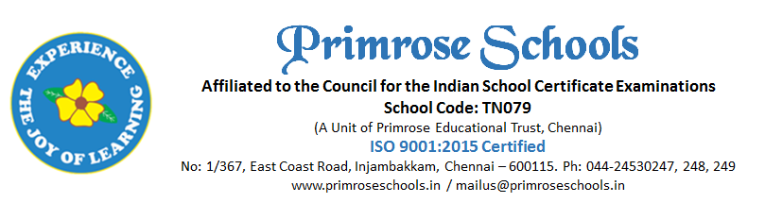
Cir.No.39/PS/INJ/C/2023-2024 20th November 2023

SPORTS - AFTER-SCHOOL PRACTICE SESSION

Dear Parent,
We are conducting the after-school practice for the games which we are planning to represent in the regional level tournaments for the next academic year 2024 – 25. Regular practice session to improve their skill in particular game and the selection for teams will happen in the due course of time. The schedule of the after-school practice session are as follows.
Days | Category | Games | Coach | Timing
MONDAY | BOYS | Kho Kho & Athletics | Viji/Gokul | 3.00Pm to 4.30Pm
 | Girls | Football, Throw Ball & Athletics | Gopal/Rajakar/gokul | 3.00Pm to 4.30Pm
TUESDAY | BOYS | Kho Kho & Athletics | Viji/Gokul | 3.00Pm to 4.30Pm
 | GIRLS | Football, Throw Ball & Athletics | Gopal/Rajakar/gokul | 3.00Pm to 4.30Pm
WEDNESDAY | BOYS | Kabaddi & Athletics |  | 3.00Pm to 4.30Pm  ** Kabaddi  4.00PM to 5.30PM
 | Girls | Football, Throw Ball, Kabaddi, Kho Kho & Athletics |  | 3.00Pm to 4.30Pm  ** Kabaddi  4.00PM to 5.30PM
THURSDAY | BOYS | Football, Kabaddi & Athletics |  | 3.00Pm to 4.30Pm  ** Kabaddi  4.00PM to 5.30PM
 | GIRLS | Kho Kho, Throw Ball, Kabaddi & Athletics |  | 3.00Pm to 4.30Pm  ** Kabaddi  4.00PM to 5.30PM
FRIDAY | BOYS | Football, Kabaddi, Kho Kho & Athletics |  | 3.00Pm to 4.30Pm  ** Kabaddi  4.00PM to 5.30PM
 | Girls | Kho Kho, Throw Ball, Kabaddi & Athletics |  | 3.00Pm to 4.30Pm  ** Kabaddi  4.00PM to 5.30PM
SATURDAY | BOYS | Football, Cricket |  | 3.00Pm to 4.30Pm  ** Cricket  Mor – 6.00Am to 7.30Am  Eve - 3.00Pm to 4.30Pm
SUNDAY | BOYS | Cricket |  | 3.00Pm to 4.30Pm

Interested parents are requested to fill the Google form using the link given below to register your ward. Each child shall participate in maximum of two games. Specific skills required for the game will be coached for the students. We request you not to skip the practice sessions. The student will be removed from the team list if he/she is not regularly attending the session. Parents are requested to drop and pick up their wards from the session. Please send enough snacks and water.

For further queries contact, Mr. Gokul Nath P.E.T. Contact no: 95000 96908 / 89391 96347.

Regards,
Principal.

