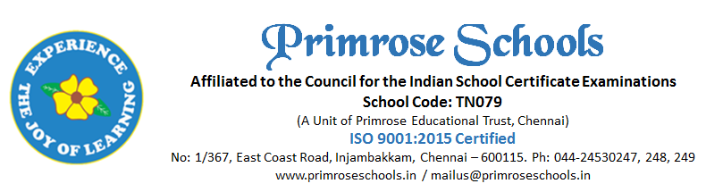

Cir.No.11/PS/INJ/C/2022-2023 13th June 2023
YOGA / KARATE CONSENT FORM – CLASSES VI TO VIII
Dear Parent,
We are happy to introduce Yoga & Karate as a part of the Co-curricular activity for the students of Classes VI to VIII from the academic year 2023 – 24 onwards. Yoga & Karate will happen parallelly during the period allocated in the timetable. You are requested to choose either Yoga or Karate as your choice for your child to practice during this year.

Student Name : ___________________________________
Class _______________________
Parent Name : ____________________________________
Your Choice of Activity for your child,
YOGA
Or
KARATE

Note: The class has to be uniformly distributed for both activities and the school cannot accommodate a greater number of children in one particular activity. In case, the choice of the students is skewed to one activity, the school reserve the right to balance the numbers and rotate the children in every other term to equally provide them opportunity to learn both activities.
Regards

Principal

