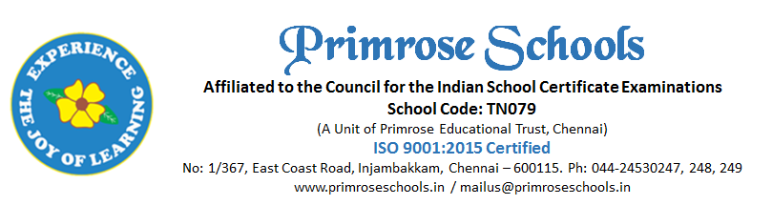

Cir.No.46/PS/INJ/C/2023-2024 08th January 2024

Dear Parents,

We would like to know your willingness to continue your ward’s education with our school for ISC (Class XI) for the academic year 2024-25. The classes will begin in the month of April 2024. Please fill the subject selection form attached along with this consent form, if you are willing to continue. Your consent will help us to plan and order the books accordingly.

Thanks
Principal
______________________________________________________________________________
PARENT CONSENT FORM
Please return this form on or before 10th January (Wednesday), 2024 to the Class teacher.

Child’s Name : ________________________________________________
Willing to Continue your ward for ISC (Class XI) Yes NO
In case if you are not joining, please let us know the reason:
___________________________________________________________________________
Parent Name : __________________________________________
Parent Sign with date : __________________________________________________

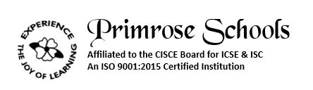
Dear Parents,
The groups offered for your child with the subjects provided. Kindly provide your choice by () mark.

MANDATORY SUBJECTS

ENGLISH LANGUAGE

ENGLISH LITERATURE

CORE 1 TO 3 : Choose one subject from each core [Mandatory]
ELECTIVE 1: Choose one subject from elective 1 [Mandatory]
ELECTIVE 2: Choose one subject from elective 2 [Optional at extra cost]

CORE 1 : Maths/Commerce/Legal Studies. Your Choice _______________________
CORE 2 : Physics/Accounts/History. Your Choice _______________________
CORE 3 : Chemistry/Economics/Business Studies/EVS Your Choice _______________________
ELECTIVE 1 : Biology/Computer Science/Physical Education/Fashion Designing.
Your Choice ________________________
ELECTIVE 2 [OPTIONAL AT EXTRA COST] :
Home Science/Art/Mass Media Communication/Psychology.

Your Choice ________________________

NOTE: If the number of students opting for any particular elective subject is less than the minimum requirement, then you will be asked to select the next elective subject of your choice.

Declaration:
I hereby provide my consent to pursue the above options for my child’s (Name)_____________________________ ISC Board Exam 2025 and certify that my selection of choice is final. I will not request for any change in subjects in the middle of the academic year 2024 – 2025.
Parent’s Signature:
Date:

