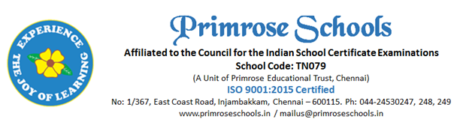

Cir.No.47/PS/INJ/C/2023-2024 20th January 2024

Educational Field Trip

Dear Parent,
The children of Class VI and VII will be going on an educational field trip to Pondicherry on 27.01.24 (Saturday). The students shall be visiting Auroville, Aurobindo Ashram and Bharathi Poonga at Pondicherry. We plan to leave the school at 5.45 am and return by late evening, at the earliest possible time. We request the parent to pay ₹1750/- towards the expenses including Travel, breakfast, lunch and evening snacks on or before 23.01.24 (Tuesday). Please return your consent form by 22.01.24 (Monday) to tell your acceptance or not. So that we can plan for the transport arrangements.

Accompanying Teachers – Ms.Pooja P , Ms.Bama , Ms.Saranya , Ms.Gitasree , Ms.Sindhuja , Ms.Mirabai , Ms.Lakshmi , Ms.Jeyalaskhmi,Ms.Akshaya , Ms.Pooja S D , Mr.Gokul , Mr.Gopal

School Contact No. – 9940189777
Teachers Contact No. –
Ms.Akshaya – 7904189091 ; Ms.Bama – 9677119117 ; Ms.Sindhuja – 8939488917 ; Mr.Gokul - 8939196347

Please send your child with neat school uniform and ID card is mandatory. Children are expected to bring enough morning snack and water. Also ensure the child wears mask and bring a spare mask in case they miss it.
Note: Parents who are not willing to send their children for field trip can have them at home on the day of field trip and they will be marked as absent in the attendance register.

Warm Regards,
Principal, Primrose Schools
-----------------------------------------------------------------------------------------------------------------------------
Parent Consent Form
Please submit this form by 22.01.24 (Monday).
Kindly pay the amount of ₹1750/- to the Accounts department on or before 23.01.24 (Tuesday).
Permission slip - Educational Field Trip to Pondicherry
Date of Field Trip – 27.01.24 (Saturday).; Child’s Name & Class _____________________

I approve of my son’s/daughter’s upcoming field trip and fully support his/her participation in it. Although each child will be closely supervised, taken utmost care by the faculty members and shall comply with all possible safety measures during the trip, I understand that in case of any injury or mishap, I should assist the school’s decision taken in the best interest of my child.

In case of emergency contact: _____________________; Phone: ________________________

___________________________________ Signature (Parent / Guardian)

